**Tail comparisons Example18**

Pegah Abedini

2023-12-22

## EXAMPLE 3.18

(Tail comparisons) Consider three loss distributions for an insurance company. Losses for the next year are estimated to be 100 million with standard deviation 223.607 million. You are interested in finding high quantiles of the distribution of losses. Using the normal, Pareto, and Weibull distributions, obtain VaR at the 99%, 99.9%, and 99.99% security levels. From the mean and standard deviation, using the moment formulas in Appendix A, the distributions and their parameters (in millions) are Normal(100, 223.607), Pareto(150, 2.5), and Weibull(50, 0.5). From the formulas for the cumulative distribution functions, the quantiles $π_{0.9}$, $π_{0.99}$, and $π_{0.999}$ are obtained. They are listed, in millions, in Table 3.1.

## Table 3.1

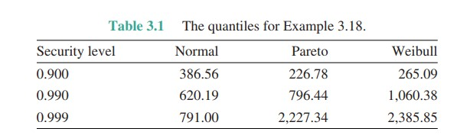

The quantiles for Example 3.18.

## Normal Distribution

Now we want to Calculate the mean and variance of data for Normal Distribution then simulation and chek them. We know(According to the Appendix A.) that if $X Normal\left(μ,sigma^{2}\right)$ then $E\left[X\right]=μ$ and $Var\left(X\right)=σ^{2}$. so if we have a dataset that show the 100$ with Standard devation 223.607 then:

and we know that

$$Var\left(X\right)=E\left[X^{2}\right]-E^{2}\left[X\right].$$

## Simulation For Normal Distribution

now we are generating ${10}^{7}$ number from Normal distribution with mean = 100 and standard devation = 223.607 with function and after that we chek the mean and standard devation of generated values with functions.

normal_numbers = rnorm(10^7 , mean = 100 , sd = 223.607)  
c(Mean = mean(normal_numbers) , Sd = sd(normal_numbers))

## Mean Sd   
## 100.0334 223.5943

## Pareto (Lomax) Distribution

we want to Calculate the mean and variance of data for Pareto Distribution then simulation and chek them. We know(According to the Appendix A.) that if $X Pareto\left(α,θ\right)$ then $E\left[X\right]=θ/\left(α-1\right)$, $E\left[X^{2}\right]=\left(2*θ^{2}\right)/\left(α-1\right)\left(α-2\right)$ and we need to calculate the variance from cross formula: $Var(X) = E[X^2] - E^2[X] $.\newline so if we have a dataset that show the 100$ with Standard devation 223.607 then:

## Pareto (Lomax) Distribution

if we supplant $θ=100\left(α-1\right)$ then we will find the $α$ value as:

### Some Mathematical realation

## Simulation for Pareto Distribution

now we are generating ${10}^{7}$ number from Pareto distribution with $α=150$ and $θ=2.5$ with function from package and after that we chek the mean and standard devation of generated values with functions.

require(VGAM)

## Loading required package: VGAM

## Loading required package: stats4

## Loading required package: splines

pareto_numbers = rlomax(10^7 , 150 , 2.5)   
c(Mean = mean(pareto_numbers) , Sd = sd(pareto_numbers))

## Mean Sd   
## 100.0534 211.0687

## Weibull Distribution

the calculations for weibull distribution have steps like as Normal and Pareto distributions. so we will find these value for our parametes:

## Simulation for Weibull Distribution

now we are generating ${10}^{7}$ number from Weibull distribution with $α=50$ and $τ=0.5$ with function and after that we chek the mean and standard devation of generated values with functions.

weibull_numbers = rweibull(10^7 , 0.5 , 50)  
c(Mean = mean(weibull_numbers) , Sd = sd(weibull_numbers))

## Mean Sd   
## 99.98069 223.49049

## Ploting The Distributions

now we want to plot the distrinutions and compare them in this four slides.

#making partitions:  
par(mfrow = c(1 , 3))  
#adding plots to partitions:  
plot(0, 0, xlim = c(-1100, 1000), ylim = c(0, 0.002),  
 type = "n" , xlab = "Loss" , ylab = "Density" ,  
 main = "Normal(100 , 223.607)")  
curve(dnorm(x, mean = 100, sd = 223.607), from = -1100,  
 to = 1000, col = 1, add = TRUE , type = "l" )  
plot(0, 0, xlim = c(0, 1000), ylim = c(0, 0.015),  
 type = "n" , xlab = "Loss" , ylab = "Density" ,  
 main = "Weibull(0.5 , 50)")  
curve(dweibull(x, 0.5, 50), from = 0, to = 1000,  
 col = 2, add = TRUE , type = "l")  
plot(0, 0, xlim = c(0, 1000), ylim = c(0, 0.02),  
 type = "n" , xlab = "Loss" , ylab = "Density" ,  
 main = "Pareto(150 , 2.5)")  
curve(dlomax(x, 150, 2.5), from = 0, to = 1000, col = 3,  
 add = TRUE , type = "l")

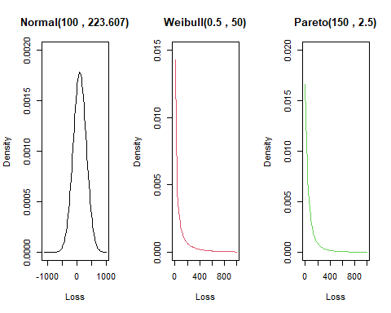

## Ploting The Distributions

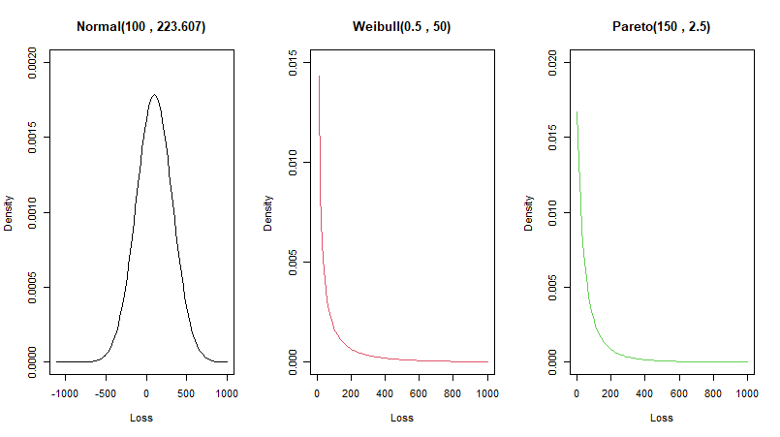

Compare Distributions Tails

## Ploting The Distributions

#change the partions to 1*1:  
par(mfrow = c(1 , 1))  
#Drow the Basic Plot (type = "n)  
plot(0, 0, xlim = c(-1100, 1000), ylim = c(0, 0.015),  
 type = "n" , xlab = "Loss" , ylab = "Density")  
#Add the Distributions Curve here:  
curve(dnorm(x, mean = 100, sd = 223.607), from = -1100,  
 to = 1000, col = 1, add = TRUE , type = "l")  
curve(dweibull(x, 0.5, 50), from = 0, to = 1000,  
 col = 2, add = TRUE , type = "l")  
curve(dlomax(x, 150, 2.5), from = 0, to = 1000,  
 col = 3, add = TRUE , type = "l")  
#Add Legend to our plot.  
legend(750, 0.015, legend=c("Normal", "Weibull" , "Pareto"),  
 col= 1:3, lty=1, cex=0.8,  
 box.lty=2, box.lwd=2, box.col="black" ,  
 text.font=4, bg='lightblue')

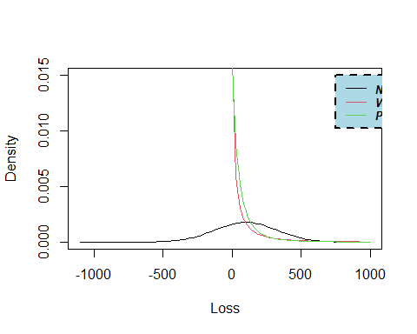

## Ploting The Distributions

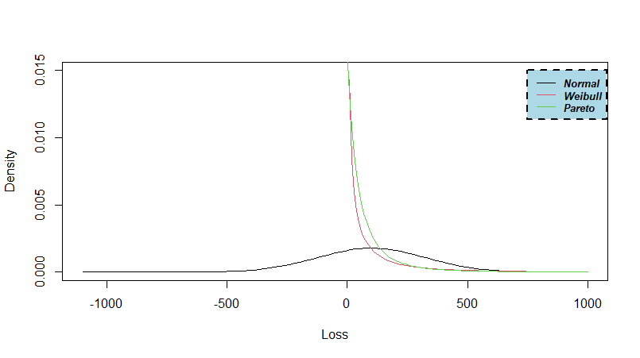

Compare Distributions Tails

## Calculate the $π_{p}$ or quantiles

according to the formulas that we learned in Book. we need to calculate the the quantiles $π_{0.9}$, $π_{0.99}$, and $π_{0.999}$ with using Cumulative distribution function. for simulating this we have to run these codes:

n = c();p = c();w = c()  
n[1] = qnorm(0.9 , 100 , 223.607)  
n[2] = qnorm(0.99 , 100 , 223.607)  
n[3] = qnorm(0.999 , 100 , 223.607)  
w[1] = qweibull(0.9 , 0.5, 50)  
w[2] = qweibull(0.99 , 0.5, 50)  
w[3] = qweibull(0.999 , 0.5, 50)  
p[1] = qlomax(0.9 , 150 , 2.5)  
p[2] = qlomax(0.99 , 150 , 2.5)  
p[3] = qlomax(0.999 , 150 , 2.5)

## Result of $π_{p}$ or quantiles

here we are making a data frame to show the results:

row_name = c("0.9" , "0.99" , "0.999")  
output = data.frame(n , p , w , row.names = row_name)  
col_name = c("Normal(100 , 223.607)"  
 , "Pareto(150 , 2.5)" , "Weibull(0.5 , 50)")  
colnames(output) = col_name  
output

## Normal(100 , 223.607) Pareto(150 , 2.5) Weibull(0.5 , 50)  
## 0.9 386.5639 226.783 265.0949  
## 0.99 620.1877 796.436 1060.3796  
## 0.999 790.9976 2227.340 2385.8541

the results are same as table 3.1.

## End